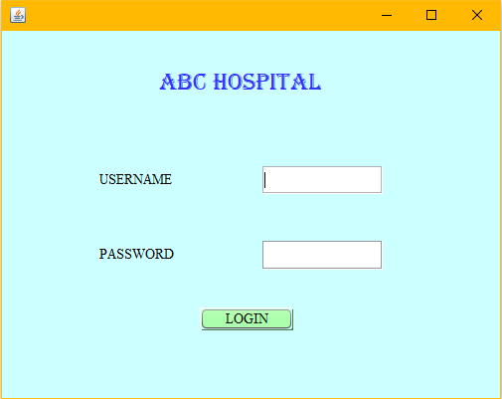

For LOGIN BUTTON:

String s1=t1.getText();

String s2=new String(p1.getPassword());

if(s1.equals("Sairam")&& s2.equals("123456"))

{

new frame2().setMaximumSize(null);

new frame2().setVisible(true);

this.setVisible(false);

}

else

{

j1.showMessageDialog(null,"Incorrect Password/Username");

}

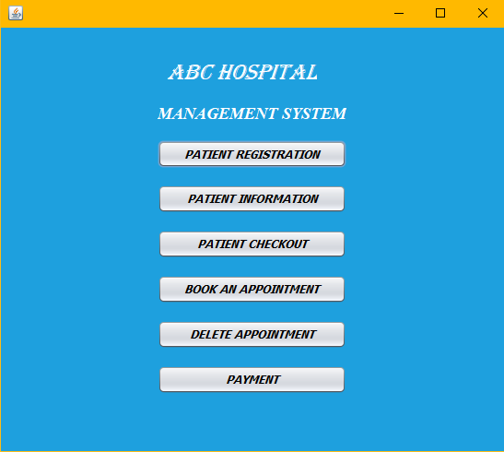

FOR PATIENT REGISTRATION BUTTON:

new Frame3().setVisible(true);

this.setVisible(false);

FOR PATIENT INFORMATION BUTTON:

new Frame4().setVisible(true);

this.setVisible(false);

FOR PATIENT CHECKOUT:

new Frame5().setVisible(true);

this.setVisible(false);

FOR BOOK AN APPOINTMENT:

new Frame6().setVisible(true);

this.setVisible(false);

FOR DELETE APPOINTMENT:

new Frame7().setVisible(true);

this.setVisible(false);

FOR PAYMENT:

new Frame8().setVisible(true);

this.setVisible(false);

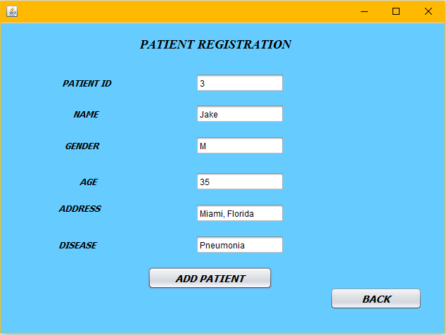

FOR ADD PATIENT BUTTON:

try{

Class.forName("com.mysql.jdbc.Driver");

Connection con=DriverManager.getConnection("jdbc:mysql://localhost:3306/hospital","root","agp3sss");

Statement stmt=(Statement)con.createStatement();

String query ="insert into patient values ("+t1.getText()+",'"+t2.getText()+"','"+t3.getText()+"',"+t4.getText()+",'"+t5.getText()+"','"+t6.getText()+"'"+");";

stmt.executeUpdate(query);

j1.showMessageDialog(null,"Record Added");

stmt.close();

con.close();

}catch(Exception e)

{

j1.showMessageDialog(null,e.getMessage());

}

FOR BACK BUTTON:

new frame2().setVisible(true);

this.setVisible(false);

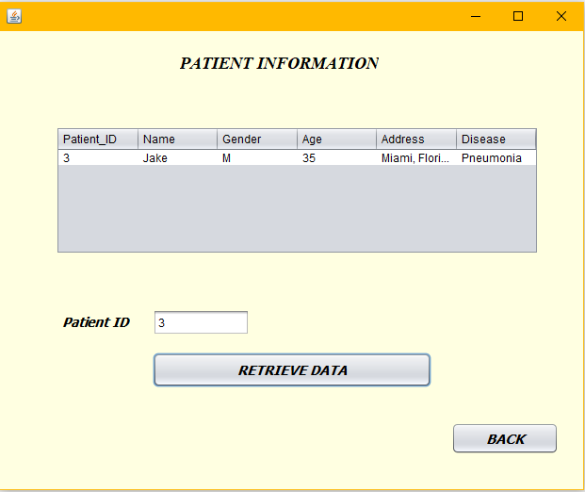

FOR RETRIEVE DATA BUTTON:

DefaultTableModel model=(DefaultTableModel) T1.getModel();

try

{

Class.forName("com.mysql.jdbc.Driver");

Connection con= DriverManager.getConnection("jdbc:mysql://localhost:3306/hospital","root","agp3sss");

Statement stmt=(Statement)con.createStatement();

String query="select * from patient where Patient_ID=("+t1.getText()+");";

ResultSet rs=stmt.executeQuery(query);

while(rs.next())

{

String PID=rs.getString("Patient_ID");

String Name=rs.getString("Name");

String Gender=rs.getString("Gender");

String Age=rs.getString("Age");

String Address=rs.getString("Address");

String Disease=rs.getString("Disease");

model.addRow(new Object[] {PID,Name,Gender,Age,Address,Disease});

}

}

catch(Exception e)

{

j1.showMessageDialog(null,e.getMessage());

}

FOR BACK BUTTON:

new frame2().setVisible(true);

this.setVisible(false);

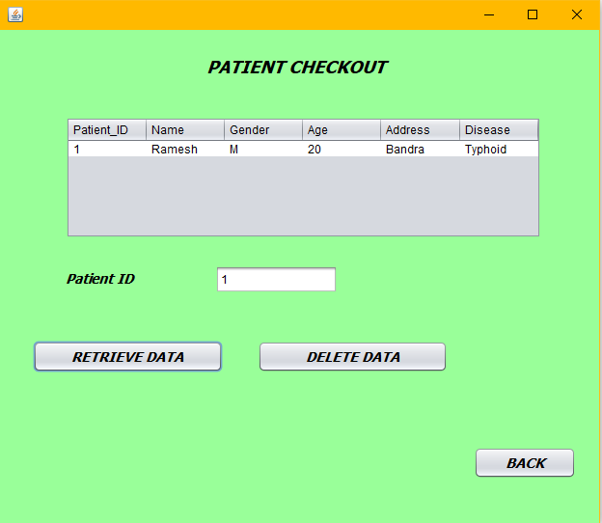

FOR RETIEVE DATA BUTTON:

DefaultTableModel model=(DefaultTableModel) T1.getModel();

try

{

Class.forName("com.mysql.jdbc.Driver");

Connection con= DriverManager.getConnection("jdbc:mysql://localhost:3306/hospital","root","agp3sss");

Statement stmt=(Statement)con.createStatement();

String query="select * from patient where Patient_ID=("+t1.getText()+");";

ResultSet rs=stmt.executeQuery(query);

while(rs.next())

{

String PID=rs.getString("Patient_ID");

String Name=rs.getString("Name");

String Gender=rs.getString("Gender");

String Age=rs.getString("Age");

String Address=rs.getString("Address");

String Disease=rs.getString("Disease");

model.addRow(new Object[] {PID,Name,Gender,Age,Address,Disease});

}

}

catch(Exception e)

{

j1.showMessageDialog(null,e.getMessage());

}

FOR DELETE BUTTON:

DefaultTableModel model=(DefaultTableModel) T1.getModel();

try

{

Class.forName("com.mysql.jdbc.Driver");

Connection con= DriverManager.getConnection("jdbc:mysql://localhost:3306/hospital","root","agp3sss");

Statement stmt=(Statement)con.createStatement();

String query="delete from patient where Patient_ID=("+t1.getText()+");";

ResultSet rs =null;

stmt.executeUpdate(query);

while(rs.next())

{

String PID=rs.getString("Patient_ID");

String Name=rs.getString("Name");

String Gender=rs.getString("Gender");

String Age=rs.getString("Age");

String Address=rs.getString("Address");

String Disease=rs.getString("Disease");

model.addRow(new Object[] {PID,Name,Gender,Age,Address,Disease});

}

}

catch(Exception e)

{

j1.showMessageDialog(null,e.getMessage());

}

FOR BACK BUTTON:

new frame2().setVisible(true);

this.setVisible(false);

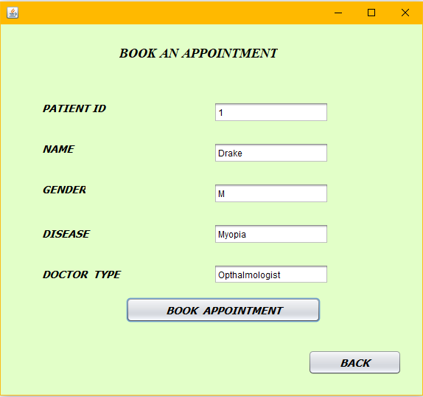

FOR BOOK AN APPOINTMENT BUTTON:

try{

Class.forName("com.mysql.jdbc.Driver");

Connection con=DriverManager.getConnection("jdbc:mysql://localhost:3306/hospital","root","agp3sss");

Statement stmt=(Statement)con.createStatement();

String query ="insert into appointment values ("+t1.getText()+",'"+t2.getText()+"','"+t3.getText()+"','"+t4.getText()+"','"+t5.getText()+"'"+");";

stmt.executeUpdate(query);

j1.showMessageDialog(null,"Record Added");

stmt.close();

con.close();

}catch(Exception e)

{

j1.showMessageDialog(null,e.getMessage());

}

FOR BACK BUTTON:

new frame2().setVisible(true);

this.setVisible(false);

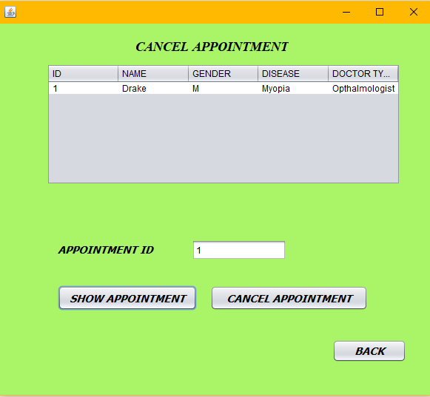

FOR SHOW APPOINTMENT BUTTON:

DefaultTableModel model=(DefaultTableModel) T1.getModel();

try

{

Class.forName("com.mysql.jdbc.Driver");

Connection con= DriverManager.getConnection("jdbc:mysql://localhost:3306/hospital","root","agp3sss");

Statement stmt=(Statement)con.createStatement();

String query="select * from appointment where ID=("+t1.getText()+");";

ResultSet rs=stmt.executeQuery(query);

while(rs.next())

{

String PID=rs.getString("ID");

String Name=rs.getString("Name");

String Gender=rs.getString("Gender");

String Disease=rs.getString("Disease");

String DT=rs.getString("Doctortype");

model.addRow(new Object[] {PID,Name,Gender,Disease,DT});

}

}

catch(Exception e)

{

j1.showMessageDialog(null,e.getMessage());

}

FOR CANCEL APPOINTMENT BUTTON :

DefaultTableModel model=(DefaultTableModel) T1.getModel();

try

{ Class.forName("com.mysql.jdbc.Driver");

Connection con= DriverManager.getConnection("jdbc:mysql://localhost:3306/hospital","root","agp3sss");

Statement stmt=(Statement)con.createStatement();

String query="delete from appointment where ID=("+t1.getText()+");";

ResultSet rs =null;

stmt.executeUpdate(query);

while(rs.next())

{

String PID=rs.getString("ID");

String Name=rs.getString("Name");

String Gender=rs.getString("Gender");

String Disease=rs.getString("Disease");

String DT=rs.getString("Doctortype");

model.addRow(new Object[] {PID,Name,Gender,Disease,DT});

}

}

catch(Exception e)

{

j1.showMessageDialog(null,e.getMessage());

}

FOR BACK BUTTON:

new frame2().setVisible(true);

this.setVisible(false);

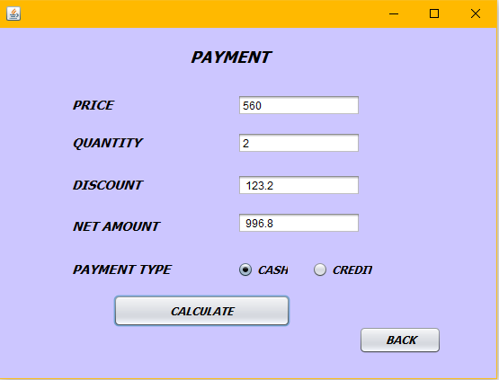

FOR CALCULATE:

try{

Class.forName("com.mysql.jdbc.Driver");

Class.forName("java.sql.Driver");

Connection con=DriverManager.getConnection("jdbc:mysql://localhost:3306/hospital","root","agp3sss");

Statement stmt=(Statement) con.createStatement();

String query="insert into payment values("+ t1.getText()+","+ t2.getText()+","+ t3.getText()+","+ t4.getText()+");";

double pr=Double.parseDouble(t1.getText());

double a=Double.parseDouble(t2.getText());

double amount = a*pr;

double discount = 0;

double net;

{

{

if(o1.isSelected()==true)

{

discount=(11*amount)/100;

}

else if(o2.isSelected()==true)

{

discount=(7*amount)/100;

}

t3.setText(" "+discount);

}

net= amount-discount;

t4.setText(" "+net);

}

stmt.executeUpdate(query);

j1.showMessageDialog(null,"RECORD ADDED");

stmt.close();

con.close();

}catch(Exception e) {

j1.showMessageDialog(null,e.getMessage());

}

FOR BACK BUTTON:

new frame2().setVisible(true);

this.setVisible(false);

MYSQL SCREENSHOTS:

PATIENT TABLE:

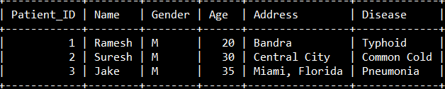

APPOINTMENT TABLE:

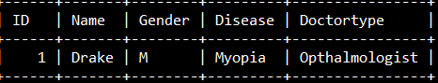

PAYMENT TABLE:

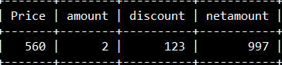

CONTENTS

1)LOGIN FORM

2)MANAGEMENT SYSTEM

3)PATIENT REGISTRATION

4)PATIENT INFORMATION

5)PATIENT CHECKOUT

6)BOOK AN APPOINTMENT

7)CANCEL APPOINTMENT

8)PAYMENT FORM

9)bIBLIOGRAPHY

Bibliography

1. www.youtube .com
2. [www.Google.com](http://www.Google.com)
3. Ncert Text Book